

Special Provision Capital Funding

Short Plan 2018-2021

(Special Educational Needs and Disability Suitability and Sufficiency Project)

**Background and Information**

The Department for Education (DfE) has conditionally allocated the County Council funding to increase school places for people aged 0-25 with an [**education and health care (EHC) plan**](http://www.lancashire.gov.uk/children-education-families/special-educational-needs-and-disabilities/education-health-and-care-plans/what-is-an-education-health-and-care-plan/)**.**

The government is giving £215 millionof funding from the [**Special Provision Capital Fund (SPCF)**](https://www.gov.uk/government/uploads/system/uploads/attachment_data/file/635760/Special-Provision-Capital-Fund-Guidance.pdf)**.**

In total the County Council could be allocated £2,049,599 in three equal instalments of £683199.66 from 2017-2021. It can only to be used to expand good or outstanding schools or create new provision.

To obtain the funding, we are instructed to publish a short plan to describe how we intend to use it.

Set out below are our findings that have formed our proposal and the short plan on what Lancashire County Council (LCC) proposes to spend the SPCF funding on. This short plan will form part of the wider Sufficiency Plan.

The Sufficiency Plan will set out Lancashire County Council's proposals in terms of how we can increase capacity across our educational estate for the benefit of Children and Young People (CYP) with Special Educational Needs and Disabilities (SEND).

It Is Proposed the Sufficiency Plan will be funded by LCC's capital investment of £6.4 million (This is DfE Basic Need grant and needs to be spent in line with the School Planning Strategy i.e. the expansion of good and outstanding schools, which would be allocated over a two year period) and an informal consultation on this Plan will start in early May 2018. The informal consultation will capture the views of children and young people, parent carers and stakeholders to shape the plan ready for potential publication 06-2018.

We have completed a full survey of our educational provision, along with an in depth data analysis of our children and young people population with special educational needs and disabilities. We have done this using money allocated previously and specified for this purpose by the DfE.

**Identifying Needs**

Based on data from 2017 there are 6384children and young people across the county who have SEND, and have an EHC plan or SEN statement

**What are Special Educational Needs?**

Special educational needs and disabilities affect a child or young persons’ ability to learn, making it harder for them to learn than most children and young people of the same age. They can affect their:

* Behaviour or ability to socialise, for example they struggle to make friends
* Reading and writing, for example because they have dyslexia
* Ability to understand things
* Concentration levels, for example because they have ADHD
* Physical ability

A child or young person has a special educational need if they need special educational provision for example extra support in nursery, school or college, help from a specialist teacher or support to attend a special school.

**Needs Analysis – Headline Figures**

In 2014 LCC supported 4997 CYP. By 2017 this figure has grown to 6362, **an increase of 27%**.

The number of CYP with social, emotional and mental health (**SEMH)** (a full explanation of this need can be found in figure 3**)** listed has increased from 669 in 2014 to 1066 in 2017. This was the sharpest rise amongst areas of need, amounting to a **county-wide** **increase of 59%.**

The **North** of the county (Lancaster, Fylde and Wyre) has experienced the most significant increase in numbers of CYP with **SEMH**, with numbers **increasing by 78%** from 2014-17 (198 to 353).

**Needs Analysis**

Since 2014 we have seen a significant increase in the number of children and young people that we support, who have SEND (figure 1).

Data shows there are potential points for improvement that will be explored further with consultation from CYP and parent carers to inform the Sufficiency Plan. Early indicators point towards:

* provision for Autistic Spectrum Disorder being increased
* Holistic education hubs for Early Years and reception age
* Outreach hubs to increase capacity for 16-19 provision

For the purpose of the SPCF the data has identified a lack of specialist provision in the North for children with a SEMH need at primary age 4-11. (Figure 2)

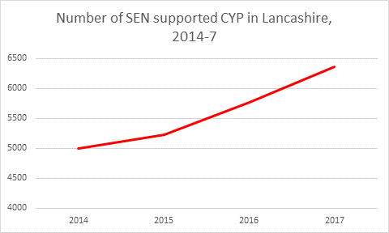

Figure 1 – Graph to show the number of SEN supported CYP from 2014 to 2017

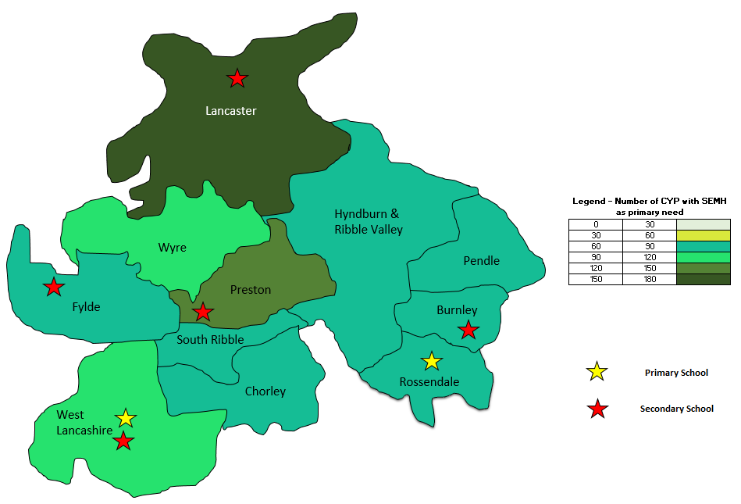

Figure 2 – Heat map showing location of specialist SEMH schools

Figure 3- explanation of SEMH

**Proposals to Meet Need**

We need to increase specialist provision in the North of the county as we do not have a specialist school for SEMH pupils aged 4-11. A high percentage of children of those with an EHC plan with a need of SEMH aged 4-11 are being educated in Independent or non-maintained schools or are attending specialist provision for General Learning Difficulties.

In the recent [Local Area Inspection](https://reports.ofsted.gov.uk/provider/files/2748553/urn/80480.pdf) in Lancashire, the a main finding was;

***"Inconsistency and variability in terms of children’s and young people’s needs being met are constant themes across the local area. Too much depends on where a child lives and which professional is involved in their situation. This results in an inequality of experience for children and young people and their families."*** (Joint Local Area SEND Inspection Report Office for Standards in Education, Children's Services and Skills (Ofsted) and Care Quality Commission (CQC), 11/13 –11/17 2018)

By increasing the capacity within the North we can:

**Figure 3**

**Social, Emotional and Mental Health Difficulties (SEMH)** Children and young people may experience a wide range of social and emotional difficulties which manifest themselves in many ways. These may include becoming **withdrawn or isolated**, as well as **displaying challenging, disruptive or disturbing behaviour**. These behaviours may reflect underlying mental health difficulties such as anxiety or depression, self-harming, substance misuse, eating disorders or physical symptoms that are medically unexplained. Other children and young people may have disorders such as **attention deficit disorder**, **attention deficit hyperactive disorder** or **attachment disorder**

* increase choice for CYP and families
* Improve outcomes for CYP with SEND
* increasingly support pupils to be part of their local community
* increase capacity in some of our specialist provision

There is a significant need for provision around social, emotional and mental health needs, particularly in the north of the County, as data suggests that the number of pupils with this need is expected to rise.

**Short Plan**

In order to develop provision that meets these needs, Lancashire County Council propose to create up to 40 new places for 4-11 year olds in the North of the county, to support pupils with social, emotional and mental health needs.

Following consultation outcomes, plans will be informed by CYP, parent carers, stake holders and feasibility studies to determine the most effective way of doing this.

|  |  |  |
| --- | --- | --- |
| **Area** | **Proposed increase in capacity**  **Proposal** | **Planned developments** |
| **Social, Emotional and Mental Health**  Meets need to increase provision to support:   * Social, emotional and mental health needs in the north of the county | | |
| North of the county (Lancaster Fylde and Wyre) | Up to 40 place special school provision for 4-11 year olds | Potential to develop an existing site set in a Northerly location. |

**Summary of Proposals**

This short plan is the first step in improving our education for children and young people aged between 0-25 in:

* creating choice
* Improving outcomes
* a consistent and equitable approach

We are passionate and committed to continuously seeking the views of children, young people, parents and carers, as these are the people that are experts in their own lives. Also by involving schools, colleges and other settings we will have the views of those who are best placed to know what is needed and what works well.

Key stakeholders will continue to be involved in the progress of this project and the wider Sufficiency Plan to provide the County Council with a clear picture of what is needed to form the basis in developing the services for the future.

**How to Have Your Say on the short plan?**

This short plan is a proposal at this stage, partly based on information gathered from the heads of special schools, short stay schools, and Special Educational Resource Facility (SERF) units as well as a wide range of data.

As a local authority we are committed to improving co-production so it is vital we have the views of children, young people and parent carers. As such, we are requesting your feedback on the proposal which can be found by following the link and completing the survey found here [Survey Link](https://www.snapsurveys.com/wh/s.asp?k=151975665130) This consultation will be open until the 25/04/2018.

Paper copies of this survey are available in different formats upon request.

We will visit Local Parent Carer forums (LPCF) to allow for face to face meetings with some of the project team. Dates and times are set out below.

**Contact us**

For any enquires regarding the short plan, Sufficiency Plan or the Special Provision Capital Fund, please call **0300 123 6706** or email lancashirelocaloffer@lancashire.gov.uk

|  |  |  |
| --- | --- | --- |
| **EAST LANCASHIRE** | | |
| **Place** | **Date** | **Time** |
| White Ash School, Thwaites Road, Oswaldtwistle BB5 4QG | Friday 16th March | 9:45am-11:45am |
| Maden Centre, Rochdale Road, Bacup, OL13 9NZ | Monday 19th March | 1:15pm-2:45pm |
| Pendle View Primary School, Gibfield Road, Colne BB8 8JT | Thursday 22nd March | 1:30pm-3pm |
| The Zone Fylde, 6 Chapel Walks, Kirkham, PR4 2TA | Wednesday 21st March | 1pm-3pm |
| Community Room, Clitheroe Fire Station, Princess Avenue, Clitheroe, BB7 2AL | Thursday 5th April | 1pm-3pm |
| Holly Grove School, Barden Lane, Burnley, BB10 1JD | Monday 16th April | 1pm-3pm |
| **NORTH LANCASHIRE** | | |
| The Zone Fylde, 6 Chapel Walks, Kirkham, PR4 2TA | Wednesday 21st March | 1pm-3pm |
| Oak Tree Children's Centre, Sydney Street, Lytham St Anne's FY8 1TR | Wednesday 18th April | 1pm-3pm |
| Great Arley School, Holly Road, Thornton Cleveleys FY5 4HH | Wednesday 25th April | 9:30am-11:15am |
| Lancaster White Cross, Training Room (downstairs) | Monday 26th March | 1-3pm |
| Garstang Library, Windsor Road, Garstang, PR3 1ED | Wednesday 14th March | 1:15pm -2:45pm |
| **SOUTH LANCASHIRE** | | |
| Chorley Central Library, Union Street, Chorley PR7 1EB | Friday 30th March | 10am-12noon |
| Sir Tom Finney Community High School, Ribbleton Hall Drive, Preston, PR2 6EE | Tuesday 10th April | 10am-12noon |
| The Grove Neighbourhood centre, Station Approach, Burscough, Ormskirk L40 0RZ | Friday 23 March | 1pm-3pm |